**Aimee Shoun**

**Game Essentials**

**Sept 2 2020**

**Research Game**

**Baby Breakout**

**Story**

* Two babies Clones are working together using each others strengths, toy guns and body fluids to defeat the evil lab scientist and escape the clone labs.

One baby is short and can get through small spaces and can also be lifted up by the big baby. The big baby can pick and throw the little baby in spots the little baby can’t reach. The player will use his controller to switch between the two babies to complete missions, solve puzzles, and complete the lab maze. The babies will shoot at small enemies who will be the other clone children in the lab. They will also defeat boss Evil Scientists. They will save their little girl baby friend from being harvested for organs.

It will be two babies working together to break out of daycare to get home to mommy. They will use there vomit and dirty diapers to fight bad evil nannies . Imaginary friend creatures will appear to help the babies by providing hints and missions.

<https://www.youtube.com/watch?v=QpnY1G3vt_0>

Very Simular to unravel because you will be using two character but you will be switching between the two. Unravel is more like a two player game where this will be strickly a one player game.

There will be objects that the babies will find that will give the babies special abilities for a temporary amount of time. Some will effect health. Some ability coins will effect damage. Some will effect the babies ability to shoot special bullets or lazers. The babies will find guns so they can upgrade their weapon through the game. The guns include sling shots, spit balls, nerf guns, water guns, and giant spit

* **Story**
  + Puzzles
  + Obstacles
  + Shooting AI enemies
  + Like skylanders
  + Save another clone baby from being harvested for organs
* **Game Mechanics** 
  + Jumping
  + Looting
  + Flying
  + Grabbing
  + Walking
  + Shooting
  + Digging
  + Looking
  + Sprinting
  + Croutching
  + Crawling
  + Falling
  + Swimming
  + Punching
  + Breaking
  + Sliding
  + Throwing
* **Aesthetic**
  + Light fun colors
  + Colorful
  + Simple textures for the tables, floor, grass, walls.
  + Fun easy going energy
  + Silly, funny, jokes
  + Gross humor
  + Kinda creepy
  + Horror humor
  + Steady even pace
  + Made for kids or young adults
  + TestTubeBabyLab
  + Fake Lab Playground
  + Lab
  + Neighborhood
  + Obstacles
  + Bushes
  + Streets
  + Tables
  + Toys
  + Organ Harvest Lab
  + Evil Scientist
  + Other babies characters
  + Cheer music
  + Spit bubbles as well as dirty diapers grenades.

**Test Tube Babies**

**Start of the Game**

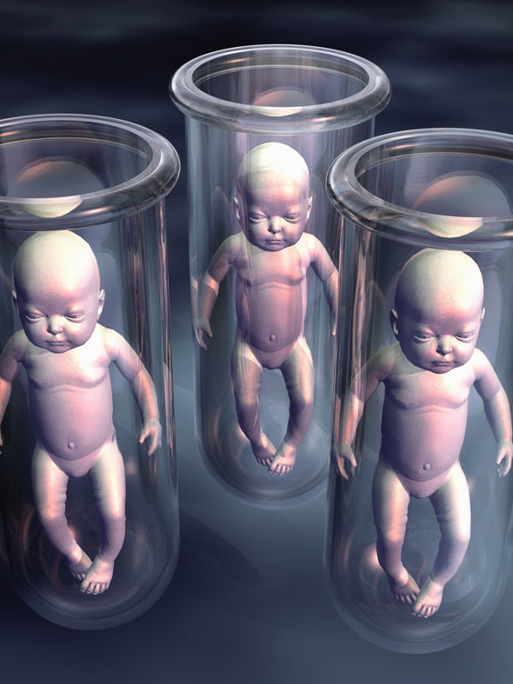

**The babies characters come from test tubes.**

**Start Game off in Test Tube.**

**You have to get out of the tube first by working together.**

**First the big baby knocks his test tube as well as the small babies test tube over.**

**This is where the mission begins.**



**The evil scientist want to harvest the babies organs.**

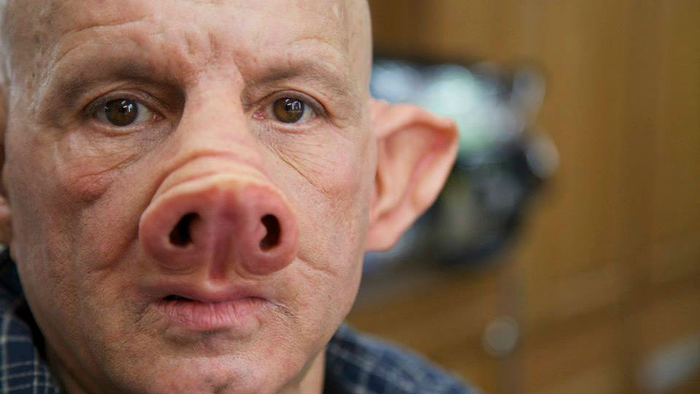

**Human Animal Hybrid (Chimaira) will be enimies that will be fighting the babies along the way.**

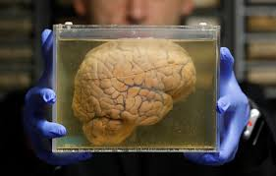

**There will be creepy labs full of organs that were harvested from previous babies. The babies will have to collect jars of organs to gain health.**

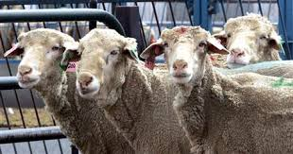

**There will be cloned sheep just as harmless characters in the background.**

I like this screen grab.

I want to use simple pixlated graphics of hearts for the health.

I also want to use building block toys to create obstacles and also direct the player where I want them to go.

I want my small enemies ( the other baby classmates) have health bar above them.

I want there to be a tracking of were you want to aim the diaper that the babies will be throwing like grenades.

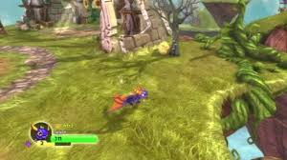 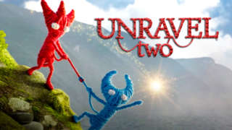

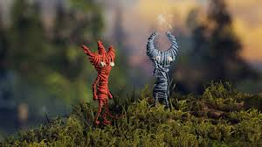

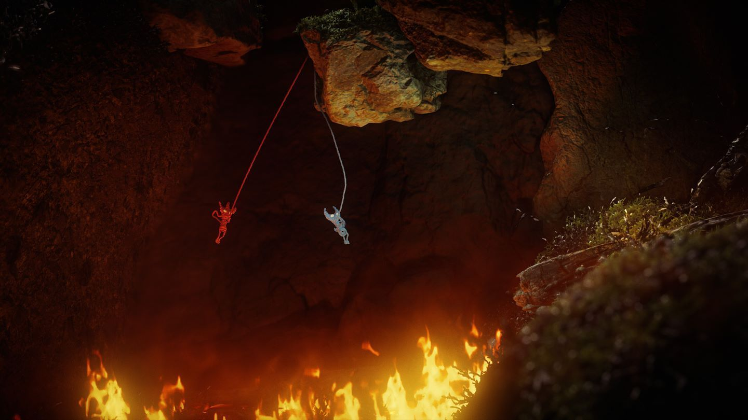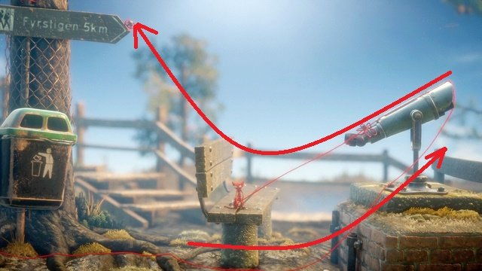 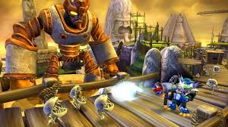

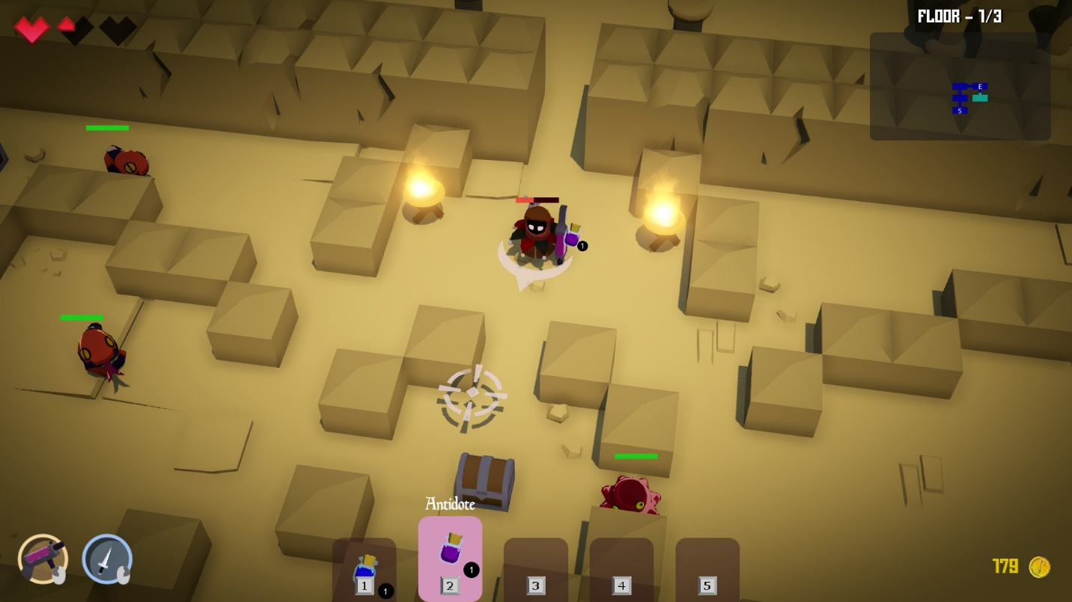

**I want to use obstacles and big objects that will block the path to direct the player were I want the player to go.**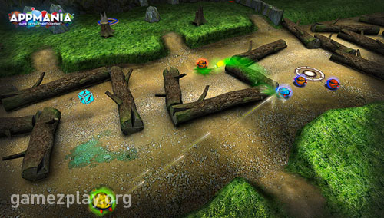

**.**

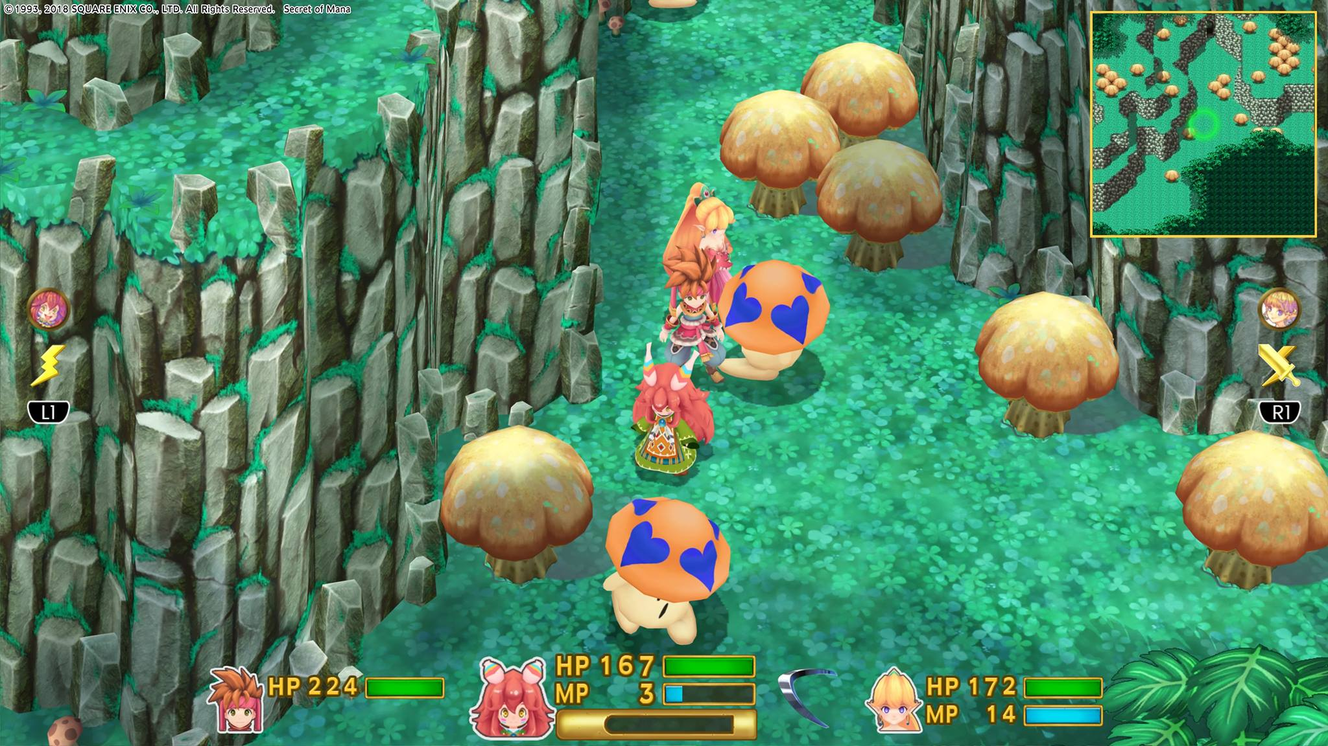

**I would like there to be a mini map that shows the players where to go and where there next objective is using a waypoint.**

**the platform will be very simular to skylanders. It will be a guided obstacle puzzle game with shootem up abilities.**

**skylander**

[**https://www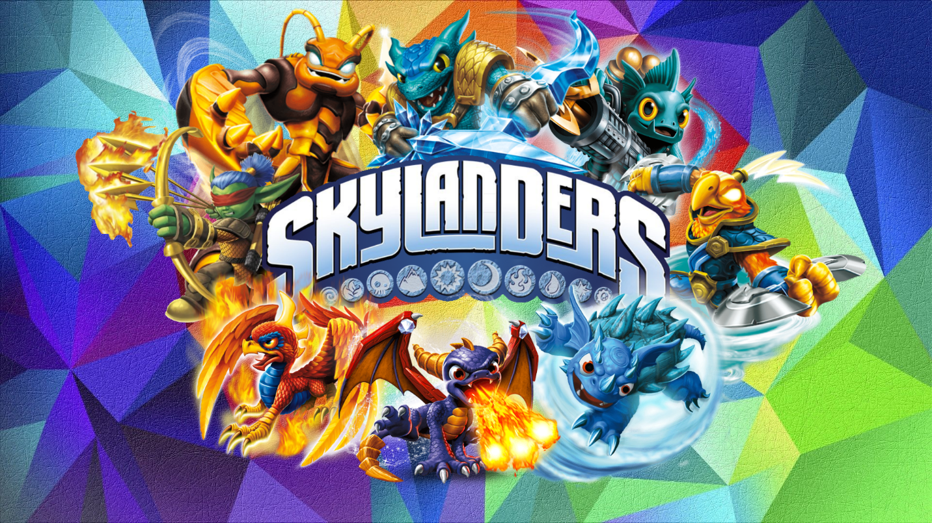.youtube.com/watch?v=HJLUx0qLpXU&t=997s**](https://www.youtube.com/watch?v=HJLUx0qLpXU&t=997s)

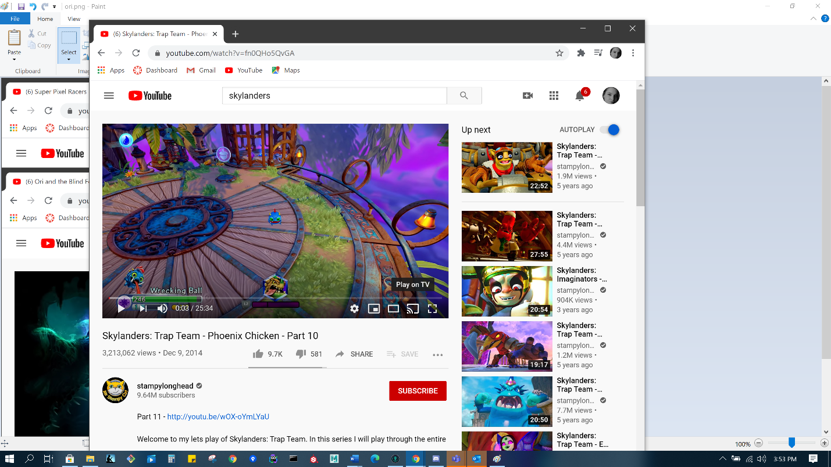

**The way the camera will follow the character is like in zelda links awakening**